**Practical - 7**

**Working with Forms**

1) Create an HTML5 Form as shown in the figure below.

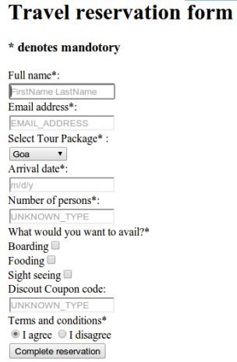

***Code*:**

<html>

<head>

<title> travel reservation form </title>

</head>

<body>

<h1>Travel Reservation Form</h1>

<h4>* denotes mendotory</h4>

<form>

Full name*:<br>

<input type="text" placeholder="FirstName LastName"><br>

EMail address*:<br>

<input type="text" placeholder="EMAIL_ADDRESS"><br>

Select Tour Package*:<br>

<select>

<option value="goa">Goa</option>

<option value="mumbai">Mumbai</option>

<option value="Diu and Daman">Diu and Daman</option>

</select><br>

Arrival date*:<br>

<input type="text" placeholder="m/d/y"><br>

Number of persons*:<br>

<input type="text" placeholder="UNKNOWN_TYPE"><br>

What would you want to avail?*<br>

<input type="checkbox" value="Boarding">Boarding<br>

<input type="checkbox" value="Fooding">Fooding<br>

<input type="checkbox" value="Sight seeing">SIght seeing<br>

Discount Coupon code:<br>

<input type="text" placeholder="UNKNOWN_TYPE"><br>

Terms and conditions*<br>

<input type="radio" name="choice" value="I agree">I agree

<input type="radio" name="choice" value="I disagree">I disagree<br>

<input type="submit" value="Complete Reservation">

</form>

</body>

</html>

***OUTPUT :-***

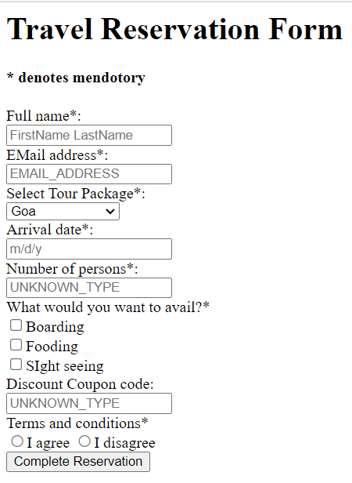

2) Create an HTML5 Form as shown in the figure below.

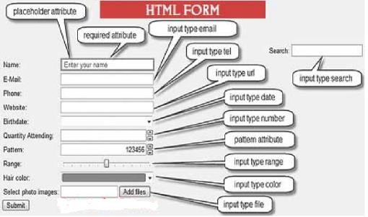

***Code:***

<html>

<head>

<title> html form </title>

</head>

<body style="text-align: center;background-color: white;">

<span style="background-color: red;color: white;font-size:

20px;">HTML FORM</span>

<form>

<table style="margin-left: auto; margin-right: auto;">

<tr>

<td>Name:</td>

<td><input type="text" placeholder="Enter your name"></td>

<td>Search</td>

<td><input type="search"></td>

</tr>

<tr>

<td>E-Mail</td>

<td><input type="email"></td>

</tr>

<tr>

<td>Phone</td>

<td><input type="tel"></td>

</tr>

<tr>

<td>Website</td>

<td><input type="url"></td>

</tr>

<tr>

<td>Birthdate</td>

<td><input type="date"></td>

</tr>

<tr>

<td>Quantity Attending</td>

<td><input type="number"></td>

</tr>

<tr>

<td>Pattern</td>

<td><input type="number" pattern="{0-9}[6]"></td>

</tr>

<tr>

<td>Range</td>

<td><input type="range"></td>

</tr>

<tr>

<td>Hair Color</td>

<td><input type="color"></td> </tr>

<tr>

<td>Select Photo Images</td>

<td><input type="file"></td>

</tr>

<tr>

<td><input type="submit" value="submit"></td>

</tr>

</table>

</form>

</body> </html>

***OUTPUT*** :-

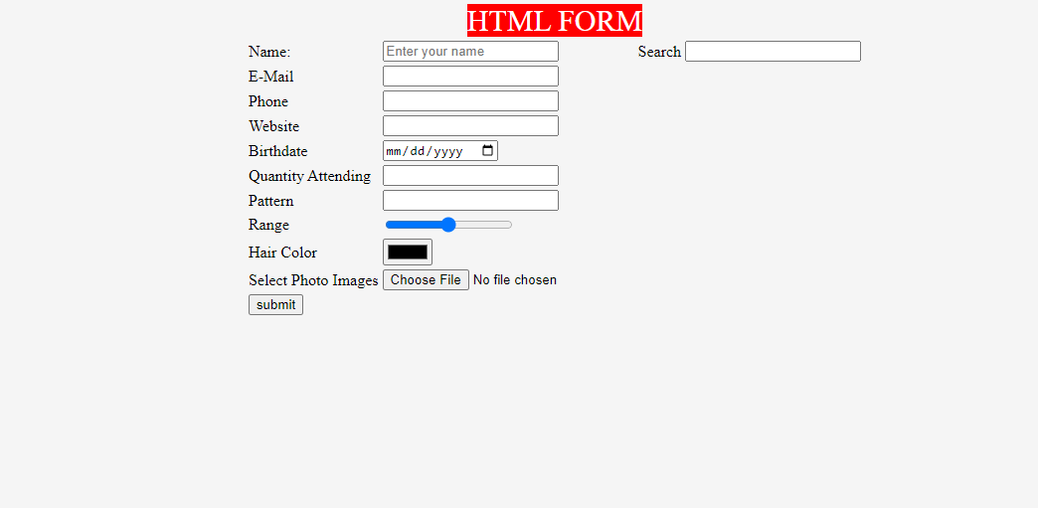

3) Create an HTML5 Form as shown in the figure below.

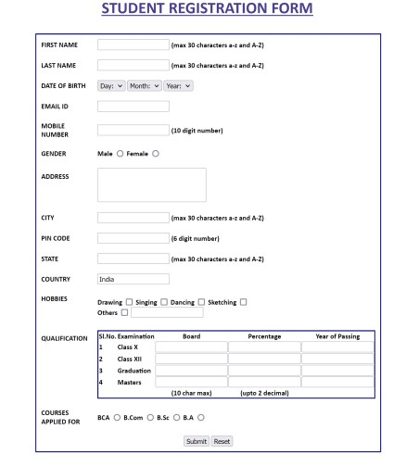

***Code*:**

<html>

<head>

<title> REGISTRATION </title>

<style> #s1 {

margin-left: 190px;

}

</style> </head>

<body>

<center>

<u style="color: blue;">

<h1 style="color: blue;">STUDENT REGISTRATION

FORM</h1>

</u>

</center>

<form style="border: 3px solid blue;">

<table>

<tr>

<td>FIRST NAME</td>

<td><input type="text" pattern="{a-zA-Z}[30]">(max 30 characters a-z and A-Z)</td>

</tr>

<tr></tr> <tr></tr> <tr></tr> <tr></tr>

<tr>

<td>LAST NAME</td>

<td><input type="text" pattern="{a-zA-Z}[30]">(max 30 characters a-z and A-Z)</td>

</tr><tr></tr> <tr></tr> <tr></tr> <tr></tr>

<tr>

<td>DATE OF BIRTH</td>

<td>

<select>

<option value="Day">Day</option>

<option value="1">1</option>

<option value="2">2</option>

<option value="3">3</option>

<option value="4">4</option>

<option value="5">5</option>

<option value="6">6</option>

<option value="7">7</option>

<option value="8">8</option>

<option value="9">9</option>

<option value="10">10</option>

<option value="11">11</option>

<option value="12">12</option>

<option value="13">13</option>

<option value="14">14</option>

<option value="15">15</option>

<option value="16">16</option>

<option value="17">17</option>

<option value="18">18</option>

<option value="19">19</option>

<option value="20">20</option>

<option value="21">21</option>

<option value="22">22</option>

<option value="23">23</option>

<option value="24">24</option>

<option value="25">25</option>

<option value="26">26</option>

<option value="27">27</option>

<option value="28">28</option>

<option value="29">29</option>

<option value="30">30</option>

<option value="31">31</option>

</select>

<select>

<option value="Month">Month</option>

<option value="January">January</option>

<option value="Febuary">Febuary</option>

<option value="March">March</option>

<option value="April">April</option>

<option value="May">May</option>

<option value="June">June</option>

<option value="July">July</option>

<option value="August">August</option>

<option value="Sepetember">Sepetember</option>

<option value="October">October</option>

<option value="November">November</option>

<option value="December">December</option>

</select>

<select>

<option value="Year">Year</option>

<option value="2018">2000</option>

<option value="2019">2001</option>

<option value="2020">2002</option>

<option value="2021">2003</option>

<option value="2022">2004</option>

<option value="2023">2005</option>

</select>

</td>

</tr><tr></tr> <tr></tr> <tr></tr> <tr></tr>

<tr>

<td>EMAIL ID</td>

<td><input type="email"></td>

</tr><tr></tr> <tr></tr> <tr></tr> <tr></tr>

<tr>

<td>MOBILE NUMBER</td>

<td><input type="number" pattern="{0-9}[10]">(10 digit number)</td>

</tr><tr></tr> <tr></tr> <tr></tr> <tr></tr>

<tr>

<td>GENDER</td>

<td>

<input type="radio" name="gender">Male

<input type="radio" name="gender">Female

</td>

</tr><tr></tr> <tr></tr> <tr></tr> <tr></tr>

<tr>

<td>ADDRESS</td>

<td>

<textarea></textarea>

</td>

</tr><tr></tr> <tr></tr> <tr></tr> <tr></tr>

<tr>

<td>CITY</td>

<td><input type="text" pattern="{a-zA-Z}[30]">(max 30 characters a-z and A-Z)</td>

</tr><tr></tr> <tr></tr> <tr></tr> <tr></tr>

<tr>

<td>PIN CODE</td>

<td><input type="number" pattern="{0-9}[6]">(6 digit number)</td>

</tr><tr></tr> <tr></tr> <tr></tr> <tr></tr>

<tr>

<td>STATE</td>

<td><input type="text" pattern="{a-zA-Z}[30]">(max 30 characters a-z and A-Z)</td>

</tr><tr></tr> <tr></tr> <tr></tr> <tr></tr>

<tr>

<td>COUNTRY</td>

<td><input type="text" placeholder="india"></td>

</tr><tr></tr> <tr></tr> <tr></tr> <tr></tr>

<tr>

<td>HOBBIES</td>

<td>

<input type="checkbox" value="drawing">Drawing <input type="checkbox" value="singing">Singing

<input type="checkbox" value="dancing">Dancing

<input type="checkbox" value="sketching">Sketching<br>

<input type="checkbox" value="others">Others<input type="text">

</td>

</tr><tr></tr> <tr></tr> <tr></tr> <tr></tr>

<tr>

<td>QUALIFICATION</td>

<td>

<table style="border: 3px solid blue;text-align: center;">

<tr>

<th>SI.No.</th>

<th>Examination</th>

<th>Board</th>

<th>Percentage</th>

<th>Year of Passing</th>

</tr>

<tr>

<td>1</td>

<td>Class X</td>

<td><input type="text"></td>

<td><input type="text"></td>

<td><input type="text"></td>

</tr>

<tr>

<td>2</td>

<td>Class XII</td>

<td><input type="text"></td>

<td><input type="text"></td>

<td><input type="text"></td>

</tr>

<tr>

<td>3</td>

<td>Graduation</td>

<td><input type="text"></td>

<td><input type="text"></td>

<td><input type="text"></td>

</tr>

<tr>

<td>4</td>

<td>Masters</td>

<td><input type="text"></td>

<td><input type="text"></td>

<td><input type="text"></td>

</tr>

<tr>

<td></td>

<td></td>

<td>(10 char max)</td>

<td>(upto 2 decimal)</td>

<td></td>

</tr>

</table>

</td>

</tr><tr></tr> <tr></tr> <tr></tr> <tr></tr>

<tr>

<td>COURSE APPLIED FOR</td>

<td>

<input type="radio" name="course">BCA

<input type="radio" name="course">B.Com

<input type="radio" name="course">B.Sc

<input type="radio" name="course">B.A

</td>

</tr><tr></tr> <tr></tr> <tr></tr> <tr></tr>

<tr>

<td></td>

<td>

<input type="submit" value="Submit">

<input type="reset" value="Reset">

</td>

</tr>

</table>

</form>

</body>

</html>

***OUTPUT :-***

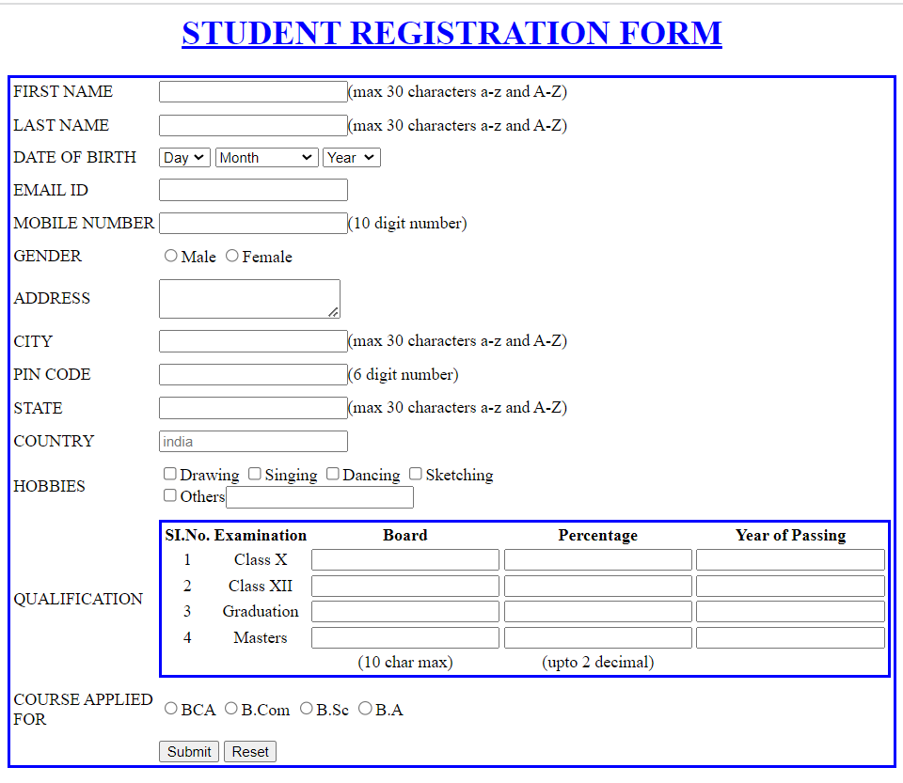

4) Create an HTML5 Form as shown in the figure below.

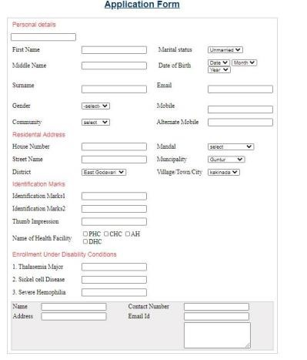

***Code:***

<html>

<head>

<title> Form </title>

</head>

<body>

<h1 style="color: violet; text-align: center;"><u>Application

Form</u></h1>

<form style="border: 3px solid black;">

<p style="color: red;">Personal Details</p>

<table>

<tr>

<td>First Name</td>

<td><input type="text"></td>

<td>Marital Status</td>

<td>

<select>

<option value="unmarried">Unmarried</option>

<option value="married">Married</option>

</select>

</td>

</tr>

<tr></tr> <tr></tr> <tr></tr> <tr></tr>

<tr>

<td>Middle Name</td>

<td><input type="text"></td>

<td>Date of Birth</td>

<td>

<select>

<option value="Day">Day</option>

<option value="1">1</option> <option value="2">2</option> <option value="3">3</option> <option value="4">4</option> <option value="5">5</option> <option value="6">6</option> <option value="7">7</option> <option value="8">8</option> <option value="9">9</option>

<option value="10">10</option>

<option value="11">11</option>

<option value="12">12</option> <option value="13">13</option> <option value="14">14</option> <option value="15">15</option> <option value="16">16</option> <option value="17">17</option> <option value="18">18</option> <option value="19">19</option> <option value="20">20</option> <option value="21">21</option> <option value="22">22</option> <option value="23">23</option> <option value="24">24</option> <option value="25">25</option> <option value="26">26</option> <option value="27">27</option> <option value="28">28</option> <option value="29">29</option> <option value="30">30</option> <option value="31">31</option>

</select>

<select>

<option value="Month">Month</option>

<option value="January">January</option>

<option value="Febuary">Febuary</option>

<option value="March">March</option>

<option value="April">April</option>

<option value="May">May</option>

<option value="June">June</option>

<option value="July">July</option>

<option value="August">August</option>

<option value="Sepetember">Sepetember</option>

<option value="October">October</option>

<option value="November">November</option> <option value="December">December</option>

</select>

<select>

<option value="Year">Year</option>

<option value="2018">2002</option> <option value="2019">2003</option> <option value="2020">2004</option> <option value="2021">2005</option> <option value="2022">2006</option> <option value="2023">2007</option>

</select>

</td>

</tr>

<tr></tr> <tr></tr> <tr></tr> <tr></tr>

<tr>

<td>Surname</td>

<td><input type="text"></td>

<td>Email</td>

<td><input type="email"></td>

</tr><tr></tr> <tr></tr> <tr></tr> <tr></tr>

<tr>

<td>Gender</td>

<td>

<select>

<option value="select">Select</option>

<option value="male">Male</option>

<option value="female">Female</option>

<option value="others">Other</option>

</select>

</td>

<td>Mobile</td>

<td><input type="tel"></td>

</tr><tr></tr> <tr></tr> <tr></tr> <tr></tr>

<tr>

<td>Community</td>

<td>

<select>

<option value="select">Select</option>

<option value="sebc">SEBC</option>

<option value="op">Open</option>

<option value="sc">SC</option>

<option value="st">ST</option>

</select>

</td>

<td>Alternate Mobile</td>

<td><input type="tel"></td>

</tr>

</table>

<p style="color: red;">Residenatl Address</p>

<table>

<tr>

<td>House Number</td>

<td><input type="number"></td>

<td>Mandal</td>

<td>

<select>

<option value="select">Select</option>

<option value="mandal">Mandal</option>

</select>

</td>

</tr><tr></tr> <tr></tr> <tr></tr> <tr></tr>

<tr>

<td>Street Number</td>

<td><input type="number"></td>

<td>Municipality</td>

<td>

<select>

<option value="select">Select</option>

</select>

</td>

</tr><tr></tr> <tr></tr> <tr></tr> <tr></tr>

<tr>

<td>District</td>

<td>

<select>

<option value="select">Select</option>

</select>

</td>

<td>Village/Town/City</td>

<td>

<select>

<option value="select">Select</option>

</select>

</td>

</tr>

</table>

<p style="color: red;">Identification Marks</p>

<table>

<tr>

<td>Identification Marks 1</td>

<td><input type="number"></td>

</tr><tr></tr> <tr></tr> <tr></tr> <tr></tr>

<tr>

<td>Identification Marks 2</td>

<td><input type="number"></td>

</tr><tr></tr> <tr></tr> <tr></tr> <tr></tr>

<tr>

<td>Thumb Impression</td>

<td><input type="text"></td>

</tr><tr></tr> <tr></tr> <tr></tr> <tr></tr>

<tr>

<td>Name of Health Facility</td>

<td>

<input type="checkbox" value="PHC">PHC

<input type="checkbox" value="CHC">CHC

<input type="checkbox" value="AH">AH<br>

<input type="checkbox" value="DHC">DHC

</td> </tr> </table>

<p style="color: red;">Enrollment Under Disability Conditions</p>

<table>

<tr>

<td>1.Thalasemaia Major</td>

<td><input type="text"></td>

</tr><tr></tr> <tr></tr> <tr></tr> <tr></tr>

<tr>

<td>2.Sickel cell Disease</td>

<td><input type="text"></td>

</tr><tr></tr> <tr></tr> <tr></tr> <tr></tr>

<tr>

<td>3.Severe Hemophila</td>

<td><input type="text"></td>

</tr><tr></tr> <tr></tr> <tr></tr> <tr></tr>

<tr style="background-color:gainsboro;">

<td style="background-color: gainsboro;">Name</td>

<td style="background-color: gainsboro;"><input type="text" style="background-color: gainsboro;"></td>

<td style="background-color: gainsboro;">Contact

Number</td>

<td style="background-color: gainsboro;"><input type="text" style="background-color: gainsboro;"></td> </tr>

<tr style="background-color: gainsboro;">

<td style="background-color: gainsboro;">Address</td>

<td style="background-color: gainsboro;"><Textarea style="background-color: gainsboro;"></Textarea></td>

<td style="background-color: gainsboro;">Email Id</td>

<td style="background-color: gainsboro;"><input type="text" style="background-color: gainsboro;"></td>

</tr>

</table>

</form>

</body>

</html>

***OUTPUT*** :-

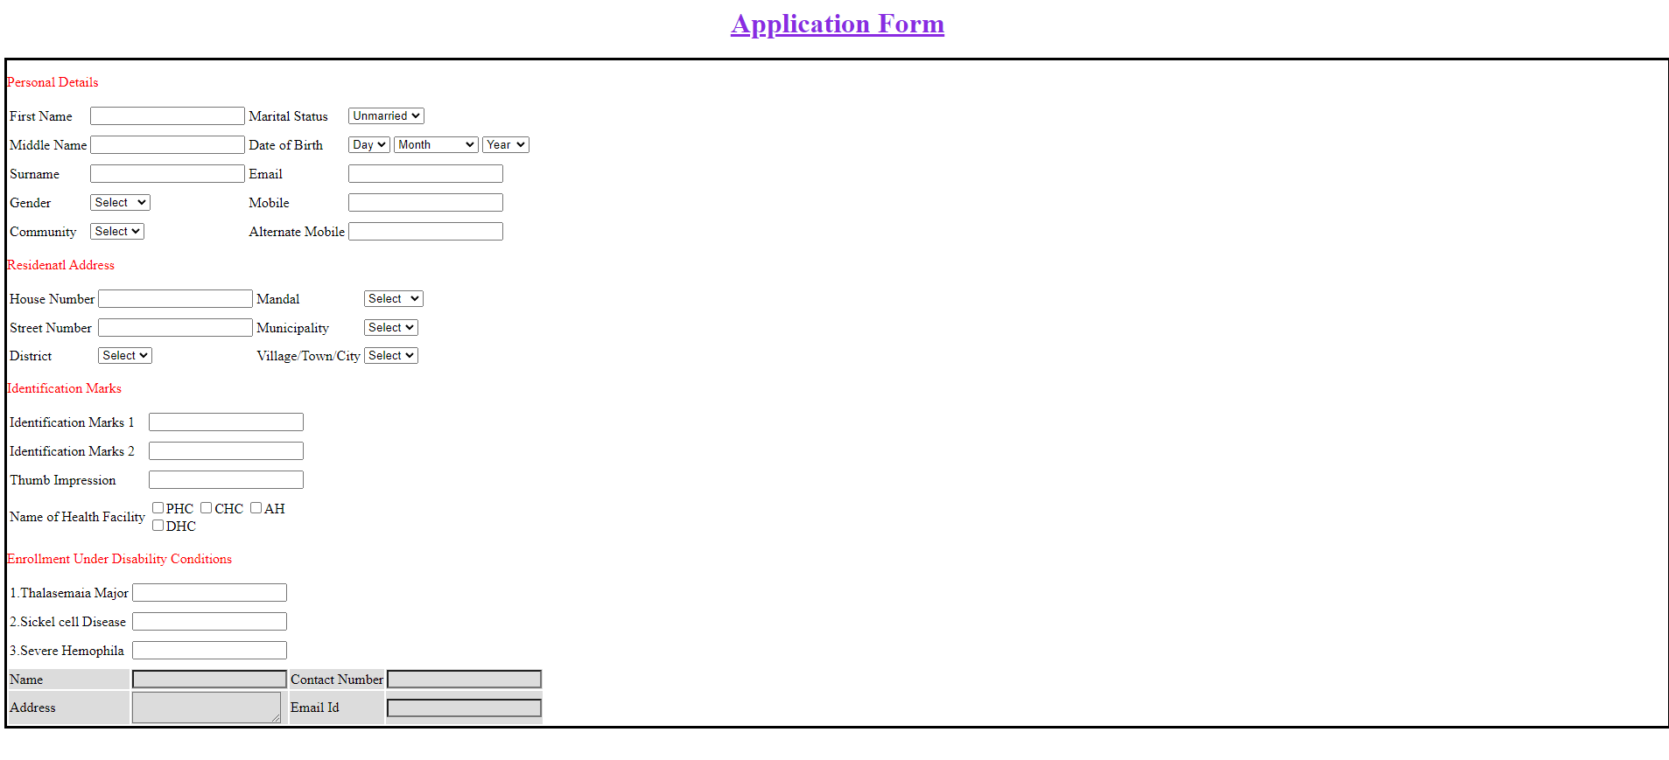

5) Create a HTML5 form as shown in the figure below.

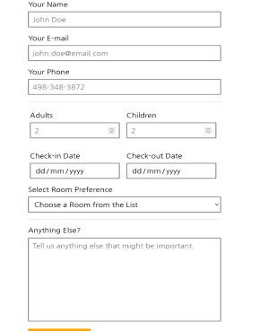

***Code*:**

<html>

<head>

<title>registration</title>

<style>

.container {

display: flex;

align-items: center;

justify-content: center;

}

.tableborder {

width: 100%;

}

</style>

</head>

<body>

<div class="container">

<form>

<label>Your Name</label><br>

<input type="text" placeholder="John Doe" style="width: 100%;"><br>

<label>Your Email</label><br>

<input type="email" placeholder="john.doe@email.com" style="width: 100%;"><br>

<label>Your Phone</label><br>

<input type="tel" placeholder="498-348-3872" style="width: 100%;">

<hr>

<table >

<tr>

<td>Adults<br></td>

<td>Children</td>

</tr>

<tr>

<td><input type="number" placeholder="2" style="margin-left:1px; margin-right: 10px;"></td></td>

<td><input type="number" placeholder="2" style="margin-right: 20px;"></td></td>

</tr>

<tr>

<td>Check-in Date</td>

<td>Check-out Date</td>

</tr>

<tr>

<td class="tableborder"><input type="date"></td>

<td><input type="date" style="margin-right: 20px;"></td>

</tr>

</table>

<label>Select Room Prefrences</label><br>

<select style="width: 50%;">

<option value="choose a room from the list">Choose a Room From The List</option>

</select><br>

<hr>

<label>Anything Else?</label><br>

<textarea cols="50" rows="10" placeholder="Tell us anything else that might be important"></textarea><br><br>

<input type="submit" value="Book The Rooms" style="background-color: yellow; height: 50px;;">

</form>

</div>

</body>

</html>

***OUTPUT*** :-

